Lab Assignment #4
Cryptography

Steffen L. Norgren <ironix@trollop.org>
A00683006

COMP 7615 • BCIT • October 20, 2009

Table of Contents
Purpose 3
Procedures 3
DES: ECB Encryption & Decryption 3
DES: CBC Encryption & Decryption 9
Comparison of DES: ECB and DES: CBC 12
ANIMAL: DES Demonstration 15
Discussion 16
Conclusion 17

Purpose
To show the difference between the DES ECB and CBC cipher variants. Additionally, to show whether there are any significant patterns in the encrypted data for either cipher that would allow a cryptologist to decipher the data.

Procedures

DES: ECB Encryption & Decryption
Open a new file and type a plain text message.

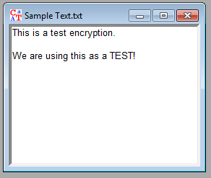
Encrypt the message using DES: ECB and the default key.
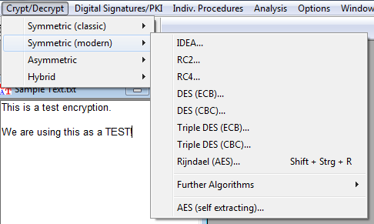
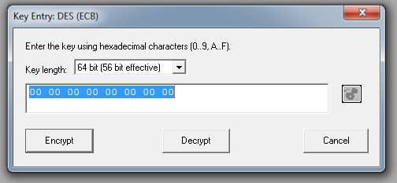
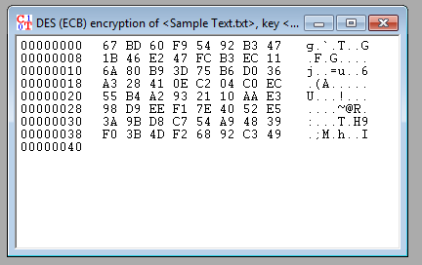
Change the view from HEX view to plain text.
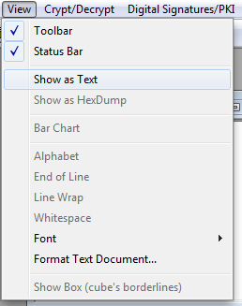
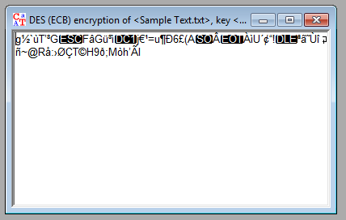
Decrypt this text using the default key.
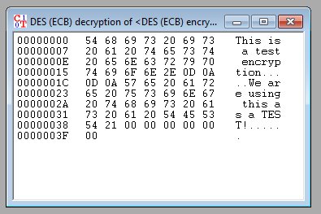
Change the view to plain text.
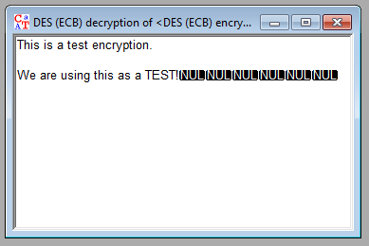

DES: CBC Encryption & Decryption
Encrypt the original text using the DES: CBC cipher.
Use the default key.
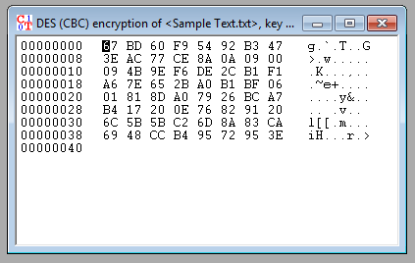
Convert the output to plain text.
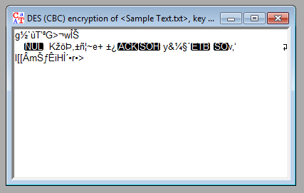
Decrypt the text using the default key and convert to plain text.
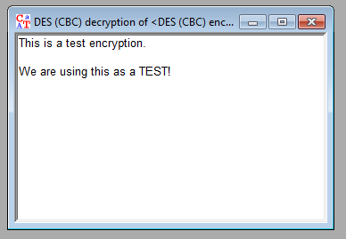

Comparison of DES: ECB and DES: CBC
Create a new text with a single word that repeats approximately 100 times.
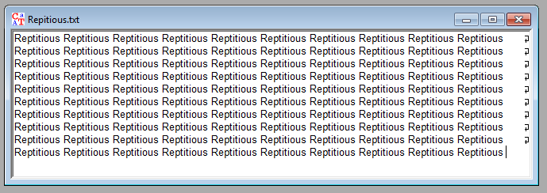
Using the procedure outlined above, encrypt the text using the DES: ECB cipher and the default key.
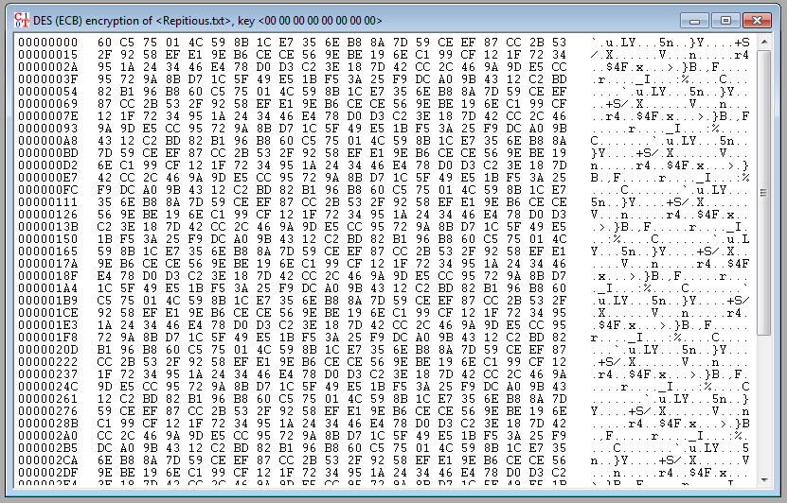
We notice that there is a repeating pattern using this cipher. Convert the output to plain text in order to see this better.
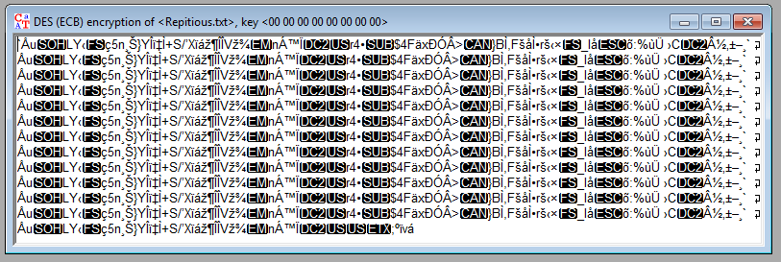
We can easily see the repeated pattern in the encrypted text. Now lets do the same, but using the DES: CBC cipher.
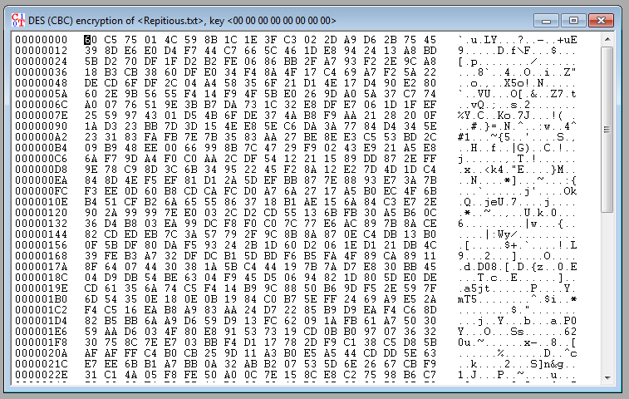
So far we don't see much of a pattern. Lets view it as plain text to be sure.
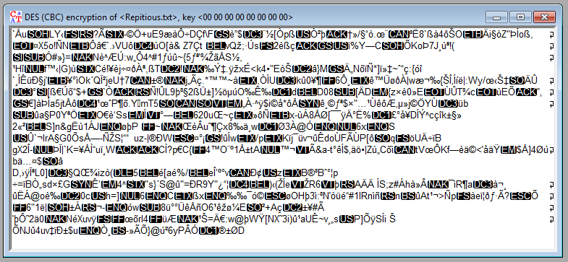
Unlike the DES: ECB cipher, the DES: CBC cipher doesn't seem to generate a repetitious pattern when encrypting a repeating series of text.

ANIMAL: DES Demonstration
View the ANIMAL: DES Demonstration.
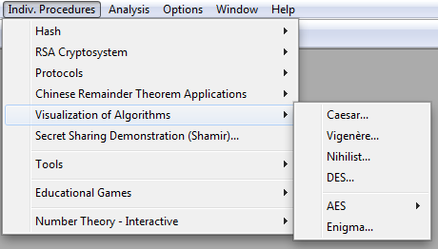
Unfortunately, as much as I tried, the demonstration would not run. I even attempted to download and install other versions of Cryptool, but nothing would work. I have a suspicion that this is because I am running 64-bit Windows 7.

Discussion
ECB encryption is the simplest form of DES. The message is divided into blocks and each block is encrypted separately. The disadvantage of this method is that identical plaintext blocks are encrypted into identical cipher text blocks; thus, it does not hide data patterns well. In some senses, it doesn't provide serious message confidentiality, and it is not recommended for use in cryptographic protocols at all.
For instance, in a text where a word is repeated over and over, encryption using the ECB method looks like this:
However, the CBC method takes each block of text to be encrypted and XORs it with the previous cipher text block before encrypting. This adds another layer of complexity to the cipher, making it far more difficult to decrypt.
For example, here is the same repetitious text from above, but encrypted using the CBC method:
As we can see, no pattern can be easily discerned in the above text. This is simply because each block to be encrypted is XORed with the previous block. This is called cipher-block chaining and is a very simply addition to the DES: ECB cipher to increase security of an encrypted text many fold.

Conclusion
Because the ECB method simply encrypts each block of text using the same key over and over, any text or data that in itself contains a pattern will also show through in the encrypted result. Because of this, cryptologists can make use of the repeating pattern to discover the cipher key and eventually decrypt the data.
However, unlike the ECB method, CBC increases the security of any encrypted data by simply adding a new layer to the encryption cipher. All the CBC cipher does to remove the visible patterns from encrypted data is to XOR each block of data to be encrypted with the previous encrypted block. As a result, we have erased any patterns innate in the data and made the cryptologists job much more difficult.

